**Digital tools for developing Innovative new products desgin**

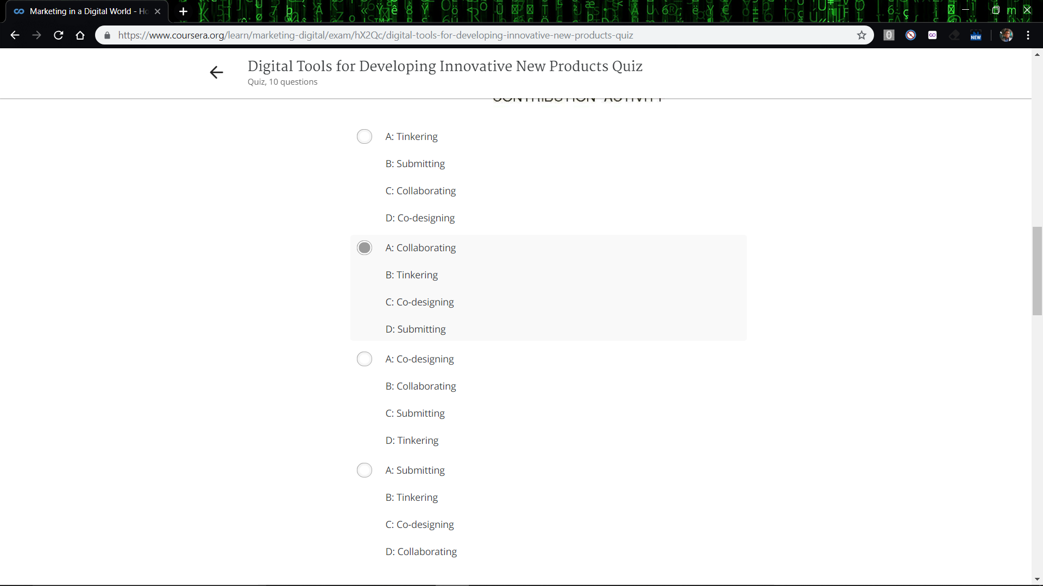

2 3 4 7 are correct

1. Not product is anything and product must have
2. Developing product to meet those needs
3. Contribution and selection
4. Check image
5. IDK
6. Not Doppelganger brand images and there are number of tool
7. All
8. Not it has the ability and individual data privacy
9. Not submission are too difficult to evaluate and come from customers
10. Not Authentic and profitable